Research on Viscoelasticity Models for Human Knee Ligaments

Stephanie Aguiar

# Introduction

This study is the initial a part of the research “viscoelasticity models for human knee ligaments”. Its principal focus is to gain knowledge in the mathematical basis to understand how the majority of viscoelasticity models works. To accomplish this objective, an extensive bibliographic revision was done, as well as, it was identified the mathematical software programs or software languages that can be used to solve them.

Furthermore, some authors have done important studies about these subjects and they will be reviewed in this section.

The viscoelastic theory is hugely used in an amount of different materials and with different applications. An article presented by (Weinerowska-Bords, 2015) presents a linear convolution-based model for viscoelastic polymer pipe.

Due to its simplicity, some researches were done in order to characterize the mechanical properties of soft tissues also with linear viscoelasticity. This was done in (Jamison, Marangoni, & Glaser, 1968) where it was presented a study of characterization of soft tissues and the linear viscoelastic model was implemented because of its usability in despite of being already known by the author’s experimental investigation with guinea pig’s skin that this theoretical model is not so compatible with the real behavior.

More recently, (Miller, 1998) the mechanical properties of the brain tissue were also characterized by the linear viscoelastic model with the objective to be applied in a finite element software. The author has a study with a non-linear development (Miller & Chinzei, 1997), but the linear model was found suitable and more useful because less parameters are needed.

Moreover, some authors preferred to fit the soft tissues mechanical properties with the quasi-linear viscoelastic theory presented by (Fung, 1993). This preference was due to the more correspondence with the observed real behavior. In (Woo, Gomez, & Ackeson, 1981) was shown the suitability of the canine medial collateral ligament with this model. (Abramowitch & Woo, 2004) used goat’s medial collateral ligaments to improve the obtainment of the quasi-linear viscoelastic theory’s constants, not using step strains. Furthermore, (Abramowitch S. D., Woo, Clineff, & Debski, 2004) also used the quasi-linear model to obtain a more suitable relaxation function for soft tissues.

The quasi-linear viscoelastic theory is suffering great development after its first presentation. Some authors show a so called adaptive quasi-linear viscoelastic model in order to make it even more correspondent with the soft tissue’s behavior. In (Nekouzadeh, Pryse, Elson, & Genin, 2007) an adequate quasi-linear simplified model was presented with a non-linear stiffness function and linear integral of Boltzmann called the “viscous strain”. The theory was proved by experimental tests with reconstructed collagen and the model was found simpler because it is not a convolution integral. Moreover, (Quaia, Ying, & Optican, 2009) tests the original quasi-linear viscoelastic model for the passive eye muscle in primates and it was found not correspondent. Therefore, the adaptive quasi-linear model was also tested, and it was found suitable.

Furthermore, (Troyer, Estep, & Puttlitz, 2011) presents a study that has a objective the improvement of the experimental method to characterize the relaxation function. So that can be done, a spinal anterior longitudinal ligament was tested in relaxation. Then, the quasi-linear viscoelastic model and the nonlinear model were presented. The improvement requires the development of a finite ramp time, that was made by an algorithm. The results of both viscoelastic models’ applications were similar, and the correction was found adequate. In addition, (Funk, Hall, Crandall, & Pilkey, 2000) shows the viscoelastic behavior of ankle ligaments and it was found to be quasi-linear correspondent until a certain strain, then it turns out to be nonlinear viscoelastic.

In a research that proves both quasi-linear and nonlinear viscoelastic theories to be incomplete, (Duenwald, Vanderby Jr, & Lakes, 2010) shows that for a soft tissue like the porcine digital tendon, only Schapery’s non-linear expression corresponds fully, since increasing stress relaxation leads to a increasing strain according to the tests. Similarly, (Provenzano P. , Lakes, Keenan, & Vanderby Jr, 2001) shows that the separation of time and strain dependence in quasi-linear viscoelastic theory is not adequate for soft tissues. Therefore, the nonlinearity of the collagen fibers made tissues is also proven.

The non-linear viscoelasticity is explained by various models and for multiple applications, not only in the soft tissue approach. Like in (Luo, Jazouli, & Vu-Khanh, 2007) where the polycarbonate is found to have a nonlinear viscoelastic behavior for most stress values and that this behavior corresponds mostly with Findley’s simplified multiple integral theory. Similarly, (Schapery R. A., 1969) and (Pipkin & Rogers, 1968) show important generalized models with single integrals that fit with more than one type of material. Yet in (Pioletti & Rakotomana, 2000) and (Provenzano P. , Lakes, Corr, & R., 2002) is presented the nonlinearity of the human knee ligaments’ viscoelasticity using continuum theory and convolutional approaches, respectively. Lastly, (Troyer, Shetye, & Puttlitz, 2012) used finite element and analytical formulations for the characterization of the nonlinear viscoelasticity of soft tissues.

Moreover, the nonlinear materials continued to be studied in (Martins, Natal Jorge, & Ferreira, 2006) with hyperelastic models, including silicone-rubber samples and pig’s muscular tissues and (Guo, Peng, & Moran, 2006) presents a composites-based hyperelastic constitutive model for soft tissues. In addition, an improved nonlinear viscoelastic model was presented with a relaxation function with less parameters and more efficiency in (Qinwu, Engquist, Solaimanian, & Yan, 2020). The last model considers the continuum theory and in an extension of the continuous-time-spectrum-based models.

Another approach for the soft tissues’ viscoelasticity is the poroviscoelastic biphasic models presented in (Fagundes & Vassoler, 2019) as applicable in tendons.

Structural analyses of viscoelastic soft tissues were done in (Sopakayang, 2010) where the viscoelasticity is considered separately of each part of the tissue structure. Also in (Davis & De Vitta, 2013) where a three dimensional model for the stress relaxation of human knee ligaments were presented in both the fiber direction and the transversal one using the continuum theory for a non-linear viscoelastic model. In addition, (De Vitta & Slaughter, 2005) with a new nonlinear constitutive model for the anterior cruciate ligament also based in continuum mechanics and concluded that the collagen fibers are the tissues’ part in charge of the most stiffness in loadings. Furthermore, (Fratzl, et al., 1998) present a complete study of the collagen’s and fibrils’ structure and mechanical properties.

Some of the studies that used finite element approach for knee ligaments are (Completo, Noronha, Oliveira, & Fonseca, 2017) that investigate the biomechanical behavior of an anterior cruciate ligament and (Pioletti, Rakotomanana, Benvenuti, & Leyvraz, 1998) that analyses the same ligament considering a 3D stress distribution.

Moreover, (Zheng, Fleisig, Escamilla, & Barrentine, 1998) introduce an analytical model for the human knee during an exercise. All the internal forces of the collateral ligaments and flexion-extension forces of the cruciate ligaments were neglected. It was found that during and exercise, there is no significant stress in the anterior cruciate ligament and the posterior cruciate ligament is stressed with knee flexion.

Now that the general view of the subject is presented, a more detailed mathematical basis will be introduced.

## Mathematical Basis

The study of viscoelasticity, mainly for soft tissues as ligaments, are based in mathematical theories that are not so well known by mechanical engineers. In this chapter, a brief introduction the mathematical theories that are used in viscoelastic models are accessed. This introduction will be more focused in the application of the theories.

### Volterra Integrals

The Volterra integrals are a mathematical definition with a great applicability, like for example in viscoelasticity (Anderssen, Davies, & Hoog, 2008) (Sullivan, Razzaghi, & Simsiriwong, 2010). This expression is useful for problems where a function needs to be found out, utilizing two other functions that are already known. Those three functions are all related by an integral.

There are two types of Volterra integrals (Gripenberg, Londen, & Staffans, 1990):

(1)

(2)

Where the first presented is called a Volterra integral of first type and the other, second type. Besides that, f(t) in both types is a known function and x(t) or x(s) is the unsolved function. K(t,s) is the so called Kernel function, that can have various formats but must always depend on two parameters.

One of the most important kind of Volterra integrals is the convolutional one. This expression is one of the various formats the Kernel function can assume (Srivastava & Buschman, 1992). Therefore, a convolutional integral can be both first and second types of Volterra integrals depending if there is a summating function or not. Other interesting difference between the first and second types is that the unknown function is presented both in the left side of the equality and in the integral.

In this case, the viscoelastic constitutive single integral models, linear, quasi-linear and non-linear and even the interconversion between creep and relaxation functions, can all be characterized as Volterra integrals. According to the ones presented in this study, they are all of first kind. Other important characteristic of the Volterra integrals that can be seen in the viscoelastic constitutive models is the variable limit of integration. The higher limit of every single integral viscoelastic model is t, that represents the present time. This time is variable, not fixed, allowing a continuous analysis of the material’s viscoelastic behavior. The t presented in the Volterra integrals (1) and (2) must also be variable (Jerri, 1985).

### Convolution

In simple words, convolution is a multiplication of functions in a certain interval. A multiplication in the frequency domain is a convolution in the time domain, according to the Laplace transform and inverse. One of the many ways to characterize the purpose of the convolution is also to shift a function over another.

Assuming a system that has an input and an output and the input is known to be an impulse. Furthermore, the multiplication of the impulsive function displaced in time and a response function of the system after this impulse generates, by a sum of all these multiplications, an output function that represents the studied structure’s natural behavior. In other words, a convolution is represented by a resultant function, that is equal to the integral of an input function evaluated in x, the variable parameter, multiplicated by the response of the unknown function after this input. This response function is known and is evaluated at t-x, that is, the variable parameter displaced by another parameter called t. This parameter that displaces x is also the parameter where the unknown function, the result of the convolution, is evaluated. Therefore, as it will be seen in the further example, the function goes t = -∞ to t = ∞. However, the convolution result only exists where both functions overlap each other.

Moreover, the both the convolution and the multiplication of two functions in the Laplace transform are commutative. The implies that, not necessarily the known response function is the one that is shifted in time and the input is the fixed one. That is:

(3)

And this equality makes sense since the result only exists in the overlapping area of both functions.

The convolutional behavior can be more simply explained by a graphic example presented in (Renaissance Research Labs, 2020). In order to do this, let us assume two functions f(x) = x3 + 2x2 + 3x + 4 and g(x) = x + 2 and plot both of them below:

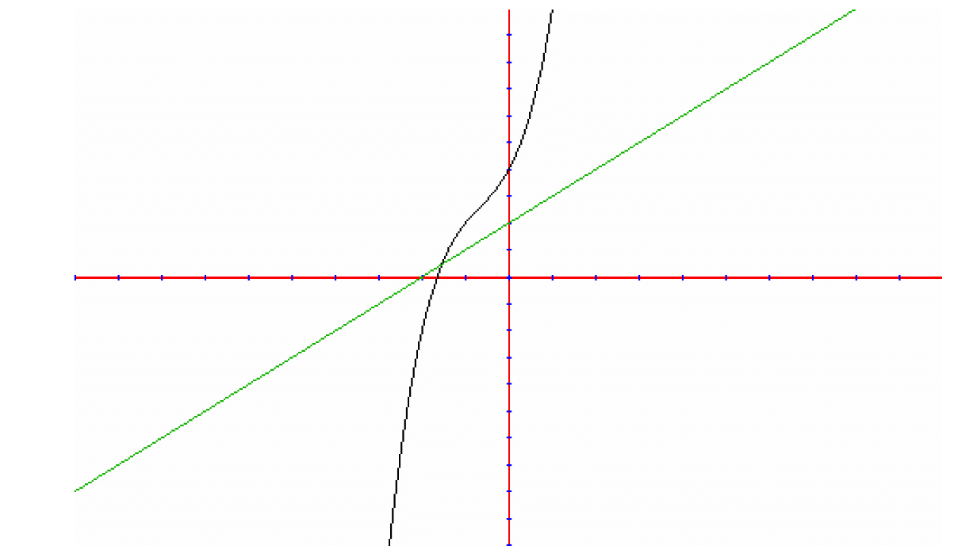

Figure Graph of f(x), the grey one, and g(x), the green one

The convolution has a similar behavior as a simple integral. It “measures” the area below a function. However, this example is a little more complicated since it involves two functions. The convolution integral represents the area below both curves. Fig.2 shows a graphical representation of this approach:

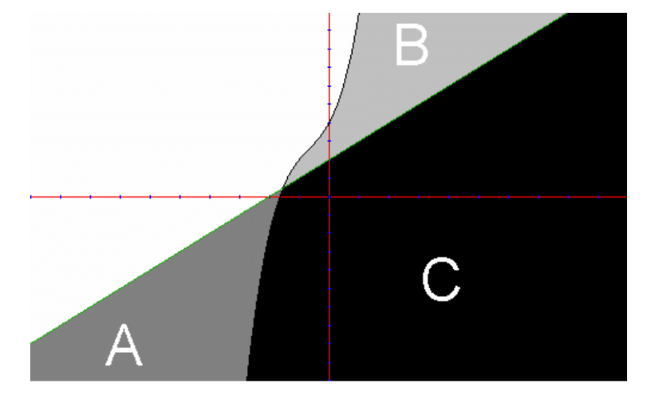

Figure Graph of f(x) and g(x) separated in colors

The area nominated by A plus the area C represents the integral of g(x), while the area called B together with the area C is the f(x) integral. It can be seen then that the area C is in intersection of both functions, this intersectional area represents the convolution between f(x) and g(t-x) integral.

Therefore, as it was seen in the previous mathematical explanation, the resultant function only exists in where both functions overlap each other. That is simply characterized by the graphic illustrated above. Although the function g(t-x) is not fixed, but goes backwards and forwards in the abscissa axis, it only exists in a certain interval.

For all this examples and explanations, it is clear a certain dependence of a parameter called t, that physically represents the time shift. This mathematical behavior indicates a physical dependency of time, since both impulse and response functions involve time as a parameter. Moreover, the result of the equation depends on the previous results, since the integration variable is time, and it goes from -∞ to the evaluated moment.

#### Types of Convolution

There are various types of convolution that can be done in a huge amount of applications. However, they turn out to be very specific in majority, and it rests only three that are interesting to be analyzed in this study.

##### Continuous Convolution

The first kind of convolution is the continuous, expressed as an integral. It is expressed, for instance, in equation (3) and it is applicable in innumerous subjects as it will be seen in the further topic. As the name and the integral suggests it is useful in situations with continuous variables and functions, when the delta variables are small enough to be considered close to zero, as a differential *dt*.

##### Discrete Convolution

The discrete convolution is expressed by a summation. As the name suggests, it is useful for discrete variables. Its properties are widely used in computer and programming applications since it is simpler for the computer or program to discretize a continuous function in innumerous parts and calculate the convolution in this way.

#### Circular Convolution

Circular convolution is also known as periodic convolution and as the name also suggests, it is valid for any sample or function resultant of a convolution that keeps repeating itself in any certain interval. It only exists for real samples or functions; an imaginary number can never be circular convoluted. (Massachusetts Institute of Technology: Department of Electrical Engineering and Computer Science, 2006). The periodic or circular convolution can be mathematically expressed by (Jerushim, Balaban, & Shanmugan, 2000):

(4)

Where hT and nT can also be considered periodic functions by:

(5)

Furthermore, for a discrete periodic convolution, it is assumed an T maximum number of different values, and the equation is written as:

(6)

The main application of this type of convolution is in computer programs, since it runs faster. The reason for this quickness is exactly the periodicity of the function, that repeats itself along the time. There are some other convolution types applied specifically for the programming field and machine learning such as the deep learning and neural network.

#### Some Applications for Convolutional Integrals

In this section more subjects that involve multiplications of functions with one of them shifted in time are presented. This is the characteristic they all have in common, but, as will be seen, these applications were from different fields of science.

##### Probability

The convolution theory is commonly used in probability and statistics in calculation of probability density functions, more specifically in the summation of the probability density functions of two random variables of a same probability space.

Now, this phenomenon will be briefly explained. Considering a probability space S and two random variables Y(S) and X(S) that are inserted in this space, we can assume each respective probability density function to be fy(Y) and fx(X). The probability density function is an integral that considers the chances of a variable to have a certain value. This curve has generally a bell format, this means that the middle values have more probability to occur than the limit values. A graphic illustration will be presented so that the probability density function can be more simply understood.

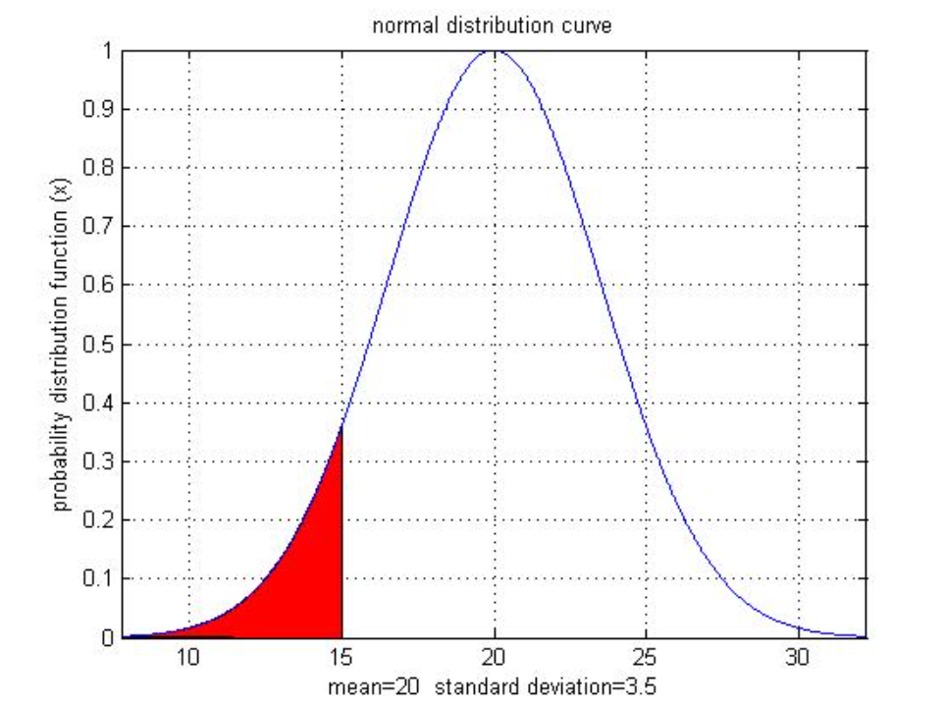

Figure Example of a probability density function (Math Works, 2020)

Where the vertical parameter represents the decimal probability and the horizontal parameter is the possible values for a certain variable. Now, that the probability function is already defined, it can be deduced the reason that this sum of function consists in a convolution. Remembering the variables Y(S) and X(S) and its probability density functions fy(Y) and fx(X), and considering an interest to evaluate the probability of occurring both Y(S) and X(S) together and naming this new variable Z = X + Y and assuming its probability density function fz(Z) = fx,y(X,Y). Therefore, the convolution of both functions is:

(7)

The last definition of the new probability function has already a convolutional format. However, if both of these variables are independent, it can be written as:

(8)

Which makes even more evident the convolutional form of this function.

#### Image processing

The image processing is another interesting application of convolutions. The images are described as matrices of the respective pixels of each part. Therefore, the convolution is done using matrices. The convolution is used to filter the image in many different types. But essentially, it is done by a weighted sum, just like the convolution integral. However, it is not a function overlapping another, but a matrix overlapping another. A kernel, how the filter matrix is called, is shifted all over the image input matrix in both vertical and horizontal axis, depending on its dimensions (Ludwig, 2020). Since the convolution properties are still valid in this example, mathematically the image input can also be shifted in the fixed filter and it would result in the same filtered image.

This convolution can be done in one-dimensional and two-dimensional cases. For 1D cases, the mathematical expression is represented by (All About Circuits, 2020):

(9)

Where y is the filtered image, x1 is the input image and x2 is the kernel or filter. This is an analogue expression of (3), but in the form of summation instead of integration since the values are all discrete. Furthermore, the mathematical expression the describes a two-dimensional image processing convolution is (All About Circuits, 2020):

(10)

Where y is the filtered image, h is the kernel and x is the image input. Moreover, i and j are correlated to the image matrix and m and n are variables of the kernel. This processing method is used to for gaussian blur, edge detection, sharpen, box blur, among other image filters.

#### Mechanical applications

The convolution integral is used in a variety of mechanical applications. The first and simpler example is a spring and dashpot system with a load and one degree of freedom. The convolution integral is used to predict the vibration of the material after a unit impulse. This behavior can be mathematically expressed as:

(11)

Where x is the displacement of the load in response to the impulse, is the unit impulse and g(t) is the natural response to an impulse from the material. The graph of both and *x*(t) can be illustrated respectively as:

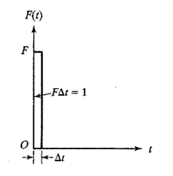 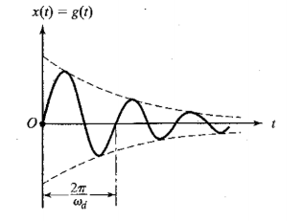

(a) (b)

Figure (a)Force per time, which the area indicates the impulse and (b) Displacement per time (Rao, 2009)

In this example, the graphic refers to x(t) = g(t) because the impulse is equal to one. Applying this unit in equation (11), this equity can be proved true.

However, these graphs and equation are valid only if the impulse is done in the origin. Since this is not the only possible case, an equation for a displaced impulse in a certain time τ, and consequently a displaced vibration, must be presented:

(12)

And the graphics turn out to be:

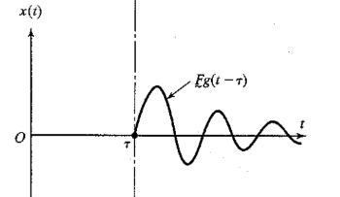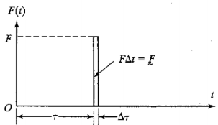

Figure (a) Force per time, which the area represents the impulse and (b) Dislocated displacement per time (Rao, 2009)

An example of this type of convolution in vibration behavior was done in MathCad and it will be presented. The constants mass (m), stiffness (k), and viscous damping coefficient (c) are equal to 500kg, 20000Pa and 500N.s/m respectively. The following expressions were input in MathCad in order to make a graphic:

(13)

Where t is time and τ is the integration variable, they are introduced as beginning in 0, and goind until t1=20s. The impulse is f(τ)=10Ns. The next variables are the natural frequency, the damping ratio and the damped natural frequency, that are respectively represented by:

(14)

(15)

(16)

Where g(t-τ) corresponds with all the expression between f(τ) and dτ. In addition, the resultant graphic is similar to the theoretical one presented in Fig. 5a:

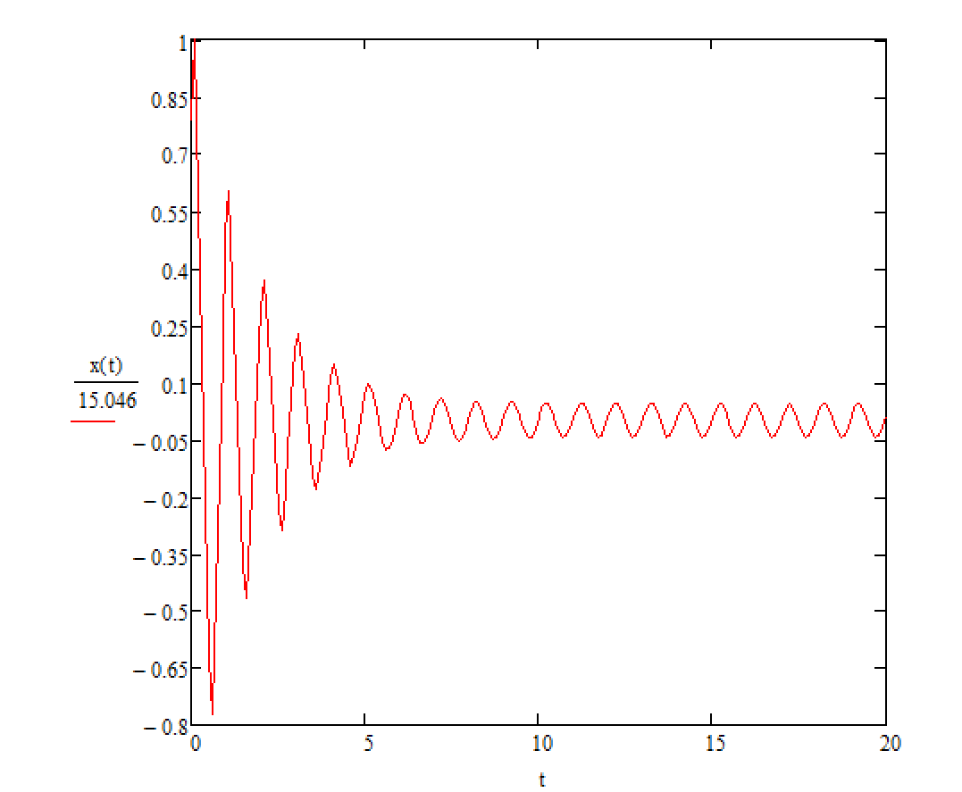

Figure Graphic of the displacement per time in a vibration made in MathCad

This concept presented in the previous example is very useful for the understanding of the next mechanical application.

It will be investigated the response of a system in a general forcing condition. In this situation, the response of the system can be considered as the sum of all the responses for theoretical impulses applied in a small time, like in equation (12), the impulses are:

(17)

Where is the force. And its summation can be illustrated by:

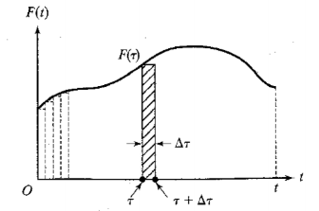

Figure Graphic of forcing per time, where the area represents the impulse or the sum of impulses (Rao, 2009)

Where τ is the same arbitrary displacement in time presented in the previous example. The summation of all the system’s responses can be described as (Rao, 2009):

(18)

This expression is a continuous convolution also known as Duhamel integral, its discrete analogue is also valid:

(19)

The function g(t) is the material’s response of an impulse. Therefore, it depends of the system, if it is elastic, damped, underdamped, and also of parameters like mass, natural frequency, among others.

###### Calculation of Mechanical Properties

In the last two examples, convolution was used to investigate the response after some impulse, due to some known material response. However, there is some other application for this powerful equation. As it was presented at the beginning of this topic, convolution can also be used to investigate the mechanical properties, due to a response to some known impulse, applied specifically for this study.

Most of solid materials have two regimes: the elastic and the plastic. In the elastic regime, the material can be modeled as spring after some input, that is, after an imposed deformation it goes back to the previous rest form. In the plastic regime, the material accumulates some residual deformation after an input, keeping a form different from the beginning (Cordeiro da Silva, 1997) (Grupo de Reelaboração do Ensino de Física, 2002). Each material has different elastic limits and it represents the maximum stress and/or strain that a material can support being able to restore its previous form, after this point the material is in the plastic regime (Britannica, 2020).

In this study, all materials will be considered only in the elastic regime. Therefore, the properties of a linear elastic solid can be calculated as:

(20)

This integral represents the stress as the response for a strain input and the stiffness or Young’s modulus as the material behavior. However, for linear elastic solids it gets simpler than that, since the stiffness is not a function of time, the expression turns out to:

(21)

This expression is called the Hookean constitutive equation. However, there is no convolution integral presented yet. For this problem is too simple since both stiffness and strain or not functions, but constants. However, there is a different kind of material that units both elasticity of solids and viscosity of liquids, that will be further explained later, and it is called a viscoelastic material. For this type of material, the mechanical properties or time dependent, making the stress, strain, and stiffness all functions.

The convolution integral has shown to be, in all of the previous examples, time dependent, since it only exists in the overlapping interval of two functions and one of them must be shifted in time. All these conducts presented in the convolution integral clearly represent a viscoelastic form. The time and history dependence are the principle characteristics of viscoelasticity phenomenon.

Thereafter, in viscoelasticity a few interesting assumptions can be made. If the relaxation function is considered to be a sum of multiple impulsive inputs in a certain interval of time between t, the first instant, and τ, the present instant. The strain rate is the input to a material with known characteristics such as the stiffness function, the output found is the stress at this interval. This method is widely used by all of three constitutive viscoelastic models: linear, nonlinear, and quasi-linear theories. From now on, all of these theories and further explanations for viscoelasticity will be presented.

### Viscoelasticity

Viscoelasticity is the behavior of a material that has both viscous and elastic properties at the same time.

Elasticity is a resistance property of a solid material during an external displacement, in order to recover its equilibrium state. Viscosity is the resistance of a fluid against a shear force, causing a greater flow velocity on the fluid surface than the one in the plane bottom.

As it will be characterized mathematically later, viscosity depends on a strain rate. This time dependence combined with the elastic characteristics results in mechanical properties with a more complex time dependency. The study of viscoelasticity is essential for the understanding the behavior of soft tissue like ligaments. The viscoelasticity models can be arbitrarily divided in linear, non-linear and quasi-linear ones.

Some basic characteristics are boarded next:

### Creep and Relaxation

There are two basic concepts that are hugely used in viscoelastic analysis: creep and relaxation, which will be defined now.

Creep occurs inputting constant stress and observing the strain’s behavior along time. Fig. 8 shows both behaviors in creep and recovery situation.

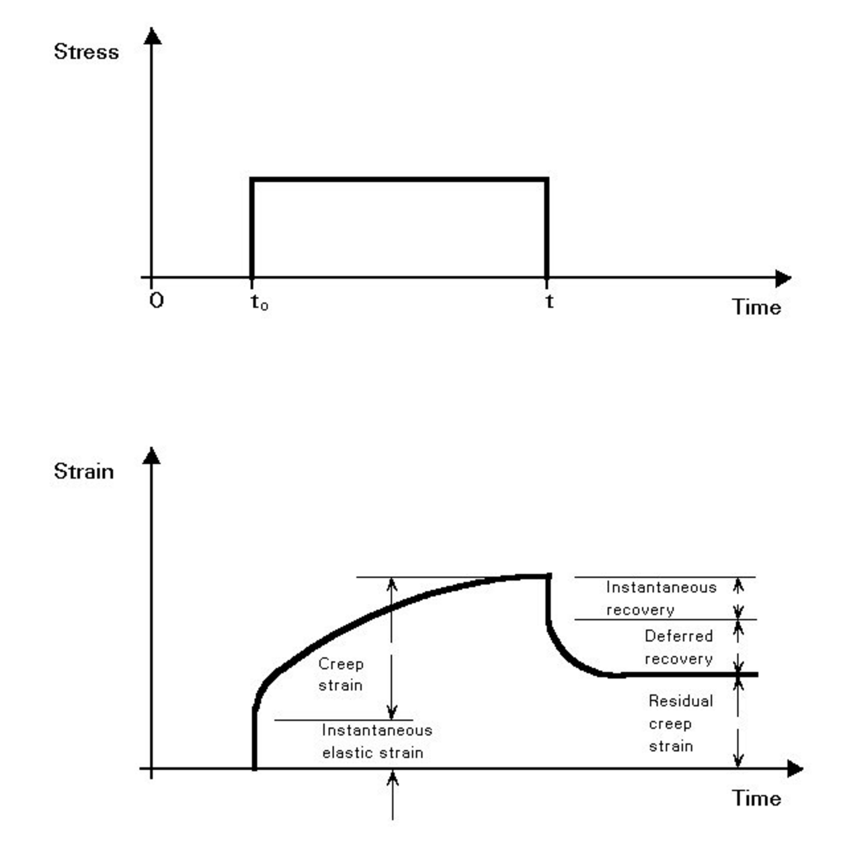

Figure Strain and Stress behavior in creep situation (COMPOSITE CONSTRUCTION, 2020)

The behavior of a linear solid in creep situation is mathematically explained by:

ε = J(t)σ0 (22)

This equation indicates that stress is constant and the creep compliance, parameter that will be exposed in detail further in this study, depends only on time. Due to that, the strain in creep depends only on creep compliance and the initial stress applied.

Relaxation occurs when a constant strain value is inputted so that the response of the stress in time is shown, as in Fig. 9.

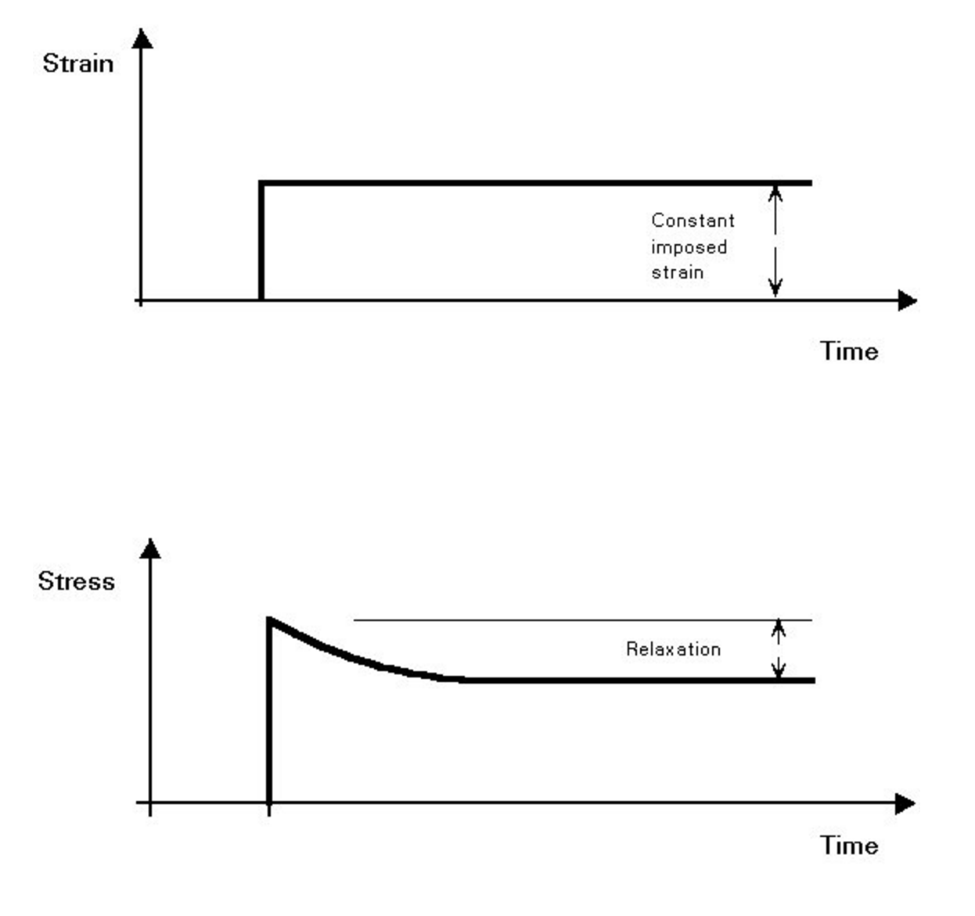

Figure Stress and strain behavior in stress relaxation situation

Relaxation, for a linear viscoelasticity behaves according to the following expression:

σ = G(t)ε0  (23)

This equation indicates the constancy of strain and that the relaxation function, that will be mathematically explained later, depends uniquely on time. In this case, stress depends only on the initial displacement (hence strain) and the relaxation time.

### Linear Models

A linear function means that it depends only on one variable parameter. In this case, a linear viscoelastic model needs to have a linear relaxation function and a linear creep compliance, that is, both these functions having only time as a variable. As it was said before in this study, both functions must depend only on time. The linear models of viscoelasticity are more commonly used for metals, but these simpler models will also be used in this study to initially understand a viscoelastic material mathematically and to be the base of the other more complex models.

#### Boltzmann’s Superposition Principle

The model here presented is based on Boltzmann’s superposition principle. This formulation defines that stresses from different strains can be summed. Assuming the stress and strain relations presented in equations (22) and (23).

Furthermore, since the initial strain is given so rapidly, that the strain rate has an impulsive form, illustrated in Fig.10:

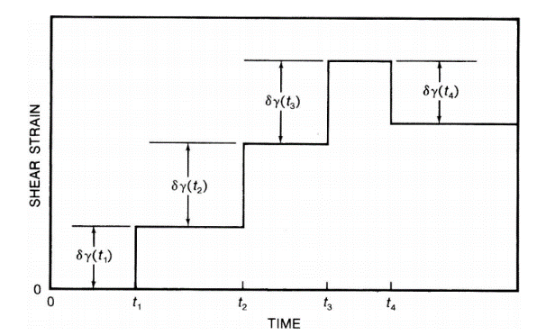

(Wang, Zhao, & Zhao, 2018)

(a)

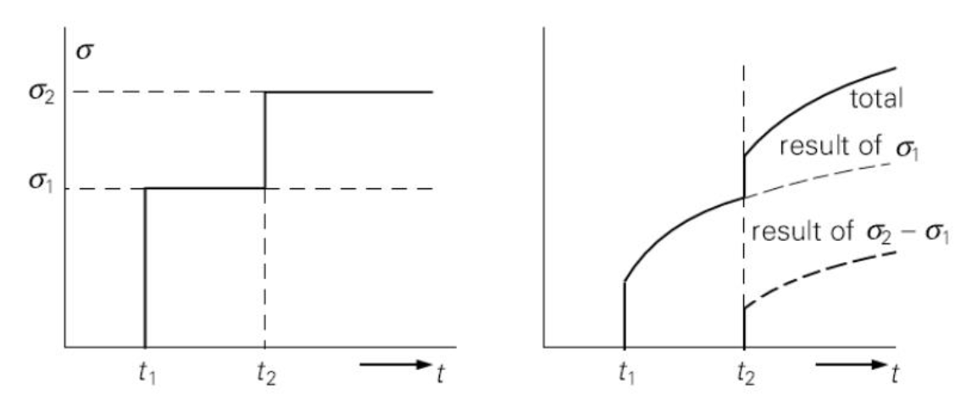

(Downs) (b)

Figure (a) shear strain per time graphic and (b) two graphs representing superposition in the stresses responsesRFRF5GY

The graphic presents δγ(tN) as the strain increment according to the time. However, in this study it will be used some specific denotations to make the equations clear. Therefore, strain is ε, stress is σ, viscosity is η, the elastic moduli is μ and the previous times are t1, t2, …, tN.

In Fig. 10, where the strain is considered to be a sum of very small step strains varying along discrete times. In order to do a superposition, like the name emphasizes, the little strains are mathematically described as an infinitesimal part and the relaxation function, that represents stiffness varying in time, is disposed in this small interval between t1 and t2 for example. Hence, the stress in this interval can be described as:

(24)

Generalizing, all the stress can be summed throughout this expression, where t is the present time. That summation can be represented by:

(25)

After defining and integrating equation 24:

(26)

The stress definition became an integral in the convolutional form.

Furthermore, the strain function can also be described by the superposition principle. Now, creep compliance is similar to relaxation function and stress rate can be compared to strain rate on the stress function.

(27)

Where J(t) is the creep compliance, time dependent that will be defined in detail further.

#### Viscoelastic models of springs and dashpots

There are two principle models that use different combinations of springs and dashpots to illustrate viscoelasticity: Kelvin and Maxwell. They will be presented next.

##### Maxwell

This model assumes that the viscoelastic material behaves as shown in Fig.11. Moreover, this will be the model used for defining linear creep compliance and relaxation function.

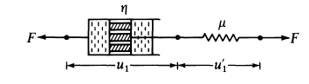 (Fung, 1993)

Figure Illustration representing a spring and a dashpot in series

Where *F* is the force, that dividing by an area that is assumed to be constant, turns in to stress (σ1 and σ2). The displacement of the dashpot and the one of the springs is respectively represented by u1 and u’1 and the viscous and elastic modulus are respectively, η and μ. However, the denotations already introduced will be the ones used on the following expressions.

According to Fig.11, it can be deduced that, using the elastic and viscosity expressions and the equilibrium of forces, assuming that the areas are all equal:

(28)

(29)

(30)

(31)

Deriving equations (28) and (30), where a dot represents the derivation on time:

(32)

(33)

Substituting (24) and (25) in (29) and adopting (26) we have:

(34)

Now the creep compliance can be assessed by, first, integrating (30) and assuming the stress rate zero in the creep phenomenon:

(35)

Then, equation (18) can be applied in (31) so that we get:

(36)

This creep compliance expression gives a strain per time, with constant strain, graphic like:

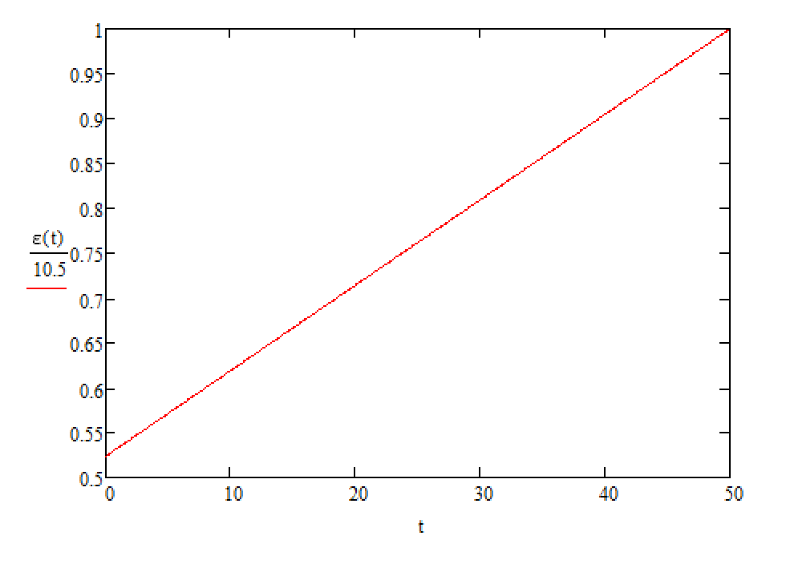

Figure strain per time Maxwell graphic in MathCad

This graphic was made using the following constants: initial stress (σ0) is 8, the viscosity (η) is 10, stiffness (μ) is 2 and time (t) goes from 0 to 10. Furthermore, the equation used was:

(37)

However, a strain per time graphic in a real linear viscoelastic material has it’s behavior like:

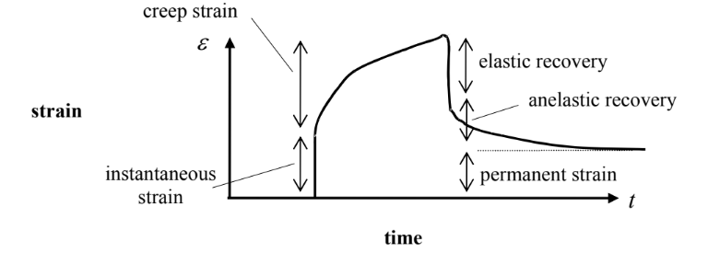

Figure Real strain per time graphic (Kelly, 2012)

And for the relaxation we can assume strain rate in equation (34) zero and we get and assume a relaxation time :

(38)

Separating stress and time variable in both sides of the equation and integrating them from 0 to t, gives:

(39)

Where σ0 is the initial stress. Applying now the Hookean constitutive equation and equation for the initial stress and equation (23) in equation (39) it can be presented:

(40)

This relaxation function represents a stiffness that reduces exponentially with time increase. The behavior above can be graphically represented by:

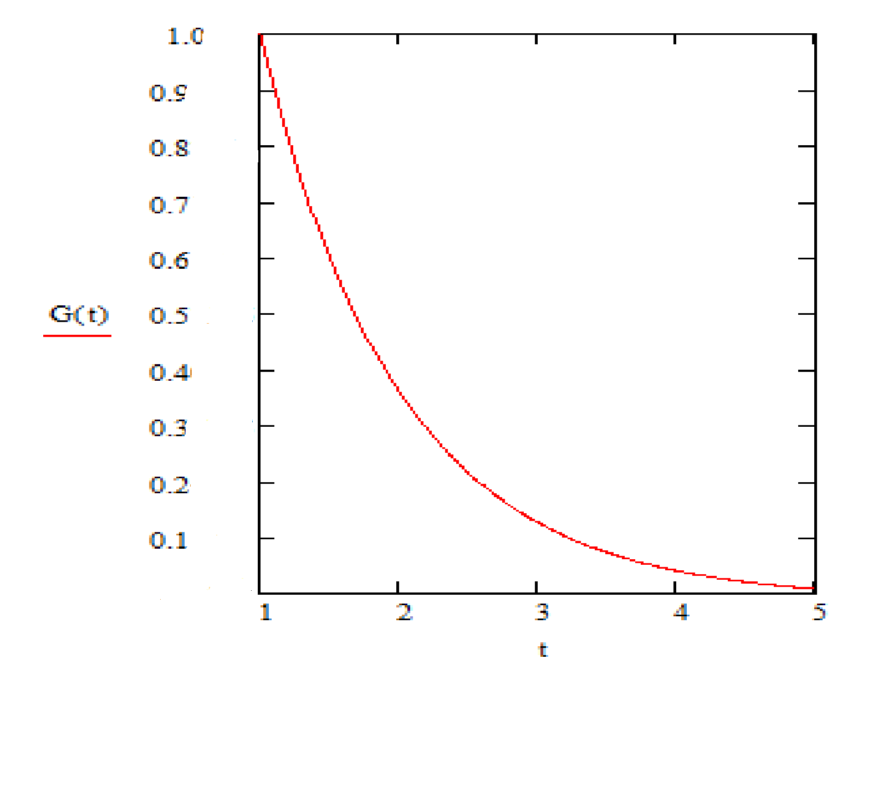

Figure Relaxation function per time in MathCad

This graphic also represents the stress behavior in a relaxation situation, which is why the name of the function is given. The similarity of these behaviors can be shown by the stress graphic in a relaxation situation:

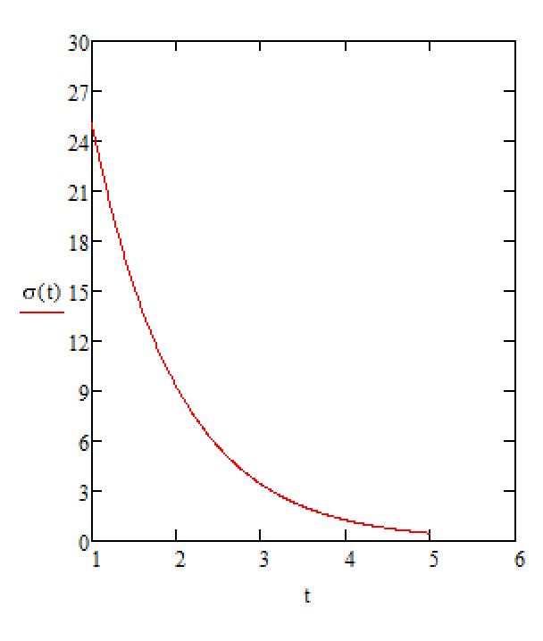

Figure Graphic of stress in a relaxation situation made in MathCad

The noticeable change in the initial value is due to the entry of the strain in the second graphic. Both graphics were done based in the constants that are initial strain (ε0) that is equal to 25, stiffness (μ) that is equal to 3, viscosity (η) that is equal to 32 and time (t) goes from 1 to 5. Furthermore, the equations used were (40) and (23).

Then, the constitutive equation for a linear Maxwell solid is:

(41)

###### Generalized Maxwell Model

The generalized Maxwell model proposes an arrangement of springs and dashpots that are series all of them in parallel. The figure below will have a clearer illustration:

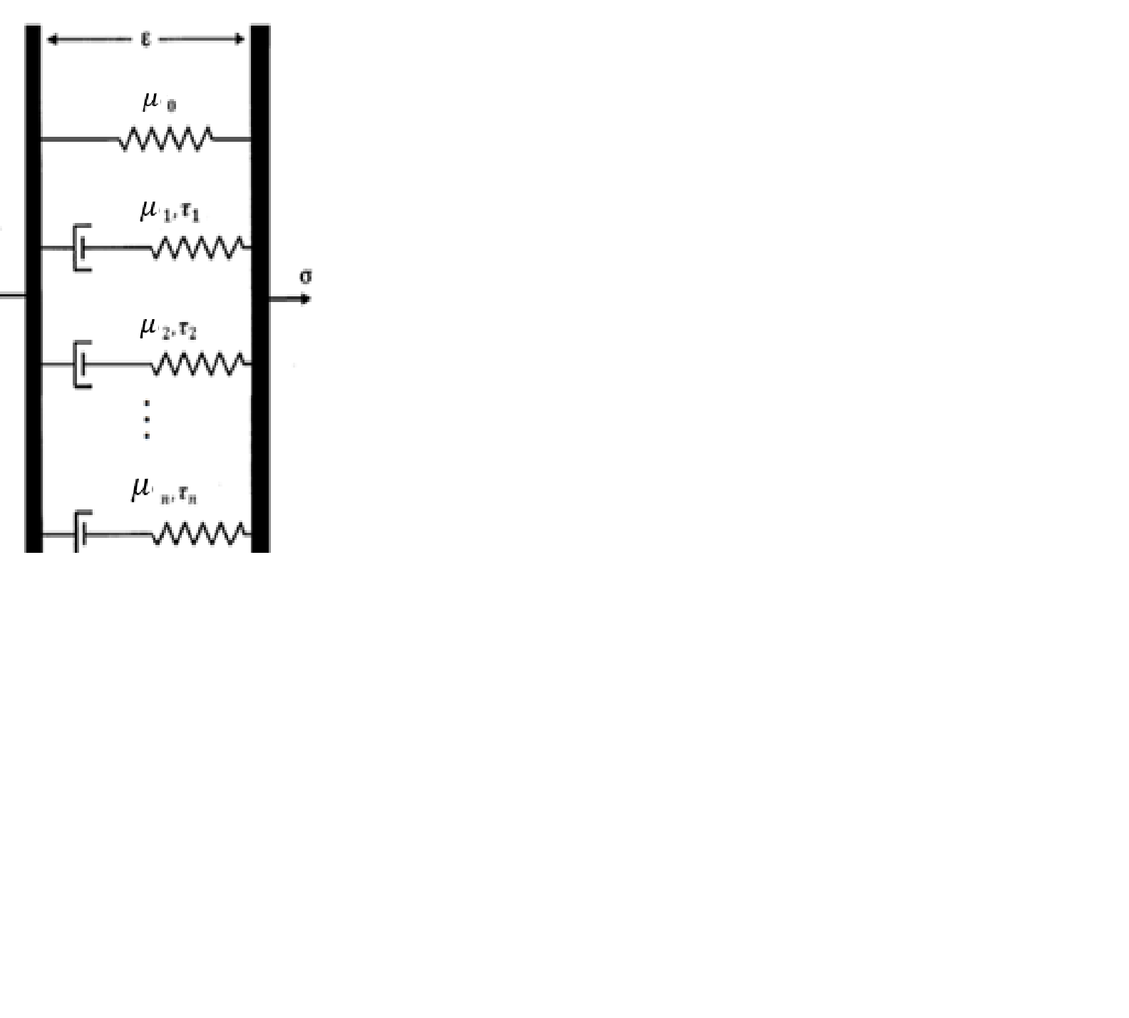

Figure Generalized Maxwell Model from (Babaei, Davarian, Pryse, Elson, & Genin, 2015) with modified code letters

This generalized model is able to analyze the constitutive behavior with a larger number of parameters, since it has more elements than the simple Maxwell. The stiffness, expressed by the relaxation function in this case is represented by:

(42)

The relaxation function is now the so called Prony series. Where μe is the relaxation modulus or Young’s modulus in an equilibrium situation, μi are the multiple Young’s modulus of each spring element and τi is the relaxation time also for each element.

Theoretically, this summation equation goes on until it reaches the equilibrium, that it, m goes further until then. However, in practical situations i only goes until 3 since further extensions do not have physical or mathematical great differences.

##### Kelvin

This model assumes a spring and a dashpot arranged in parallel, as the Fig. 17 shows:

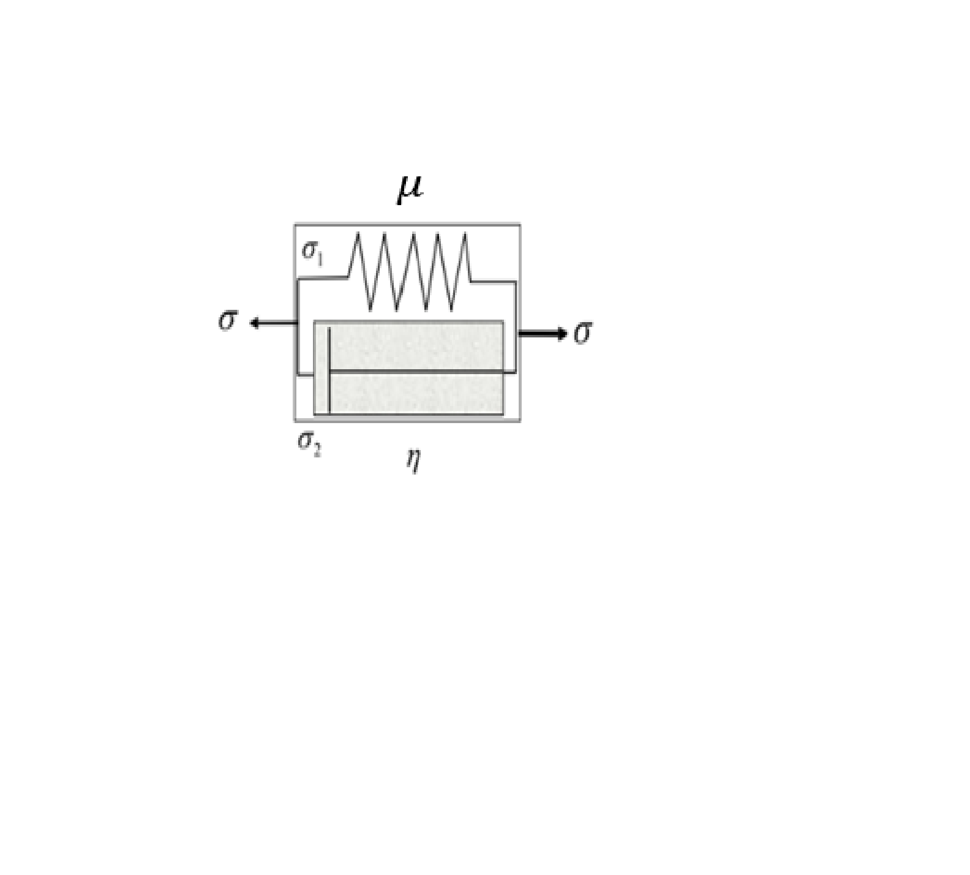(Kelly, 2012)

Figure Illustration of a spring and a dashpot arranged in parallel with modified code letters

The parallel arrangement, assuming again the Hookean and Newtonian expressions for springs and dashpots and the equilibrium of forces with equal areas, implicates in.

(43)

(44)

(45)

Applying (43) in (41) and (42):

(46)

The creep compliance equation can also be expressed according to the Kelvin viscoelastic linear model. Given the constitutive equation (45) and the proposition of this model, some initial points can be assumed, like ε(0) = 0, among this the differential equation (46) can be solved, with the solution:

(47)

Giving than a creep compliance expressed by:

(48)

This found strain can be represented graphically by:

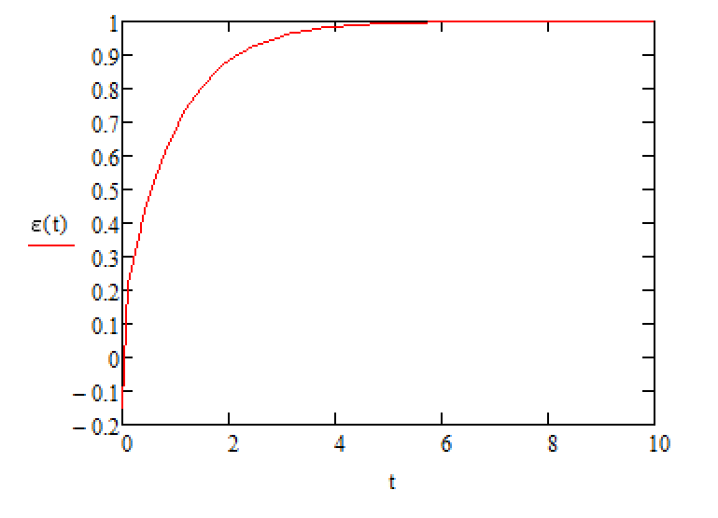

Figure strain per time graph Kelvin in MathCad

This graphic is more corresponding to the theoretical one presented in Fig. 13, so the Kelvin’s creep compliance will be the one applied in this study. In addition, the graphic was made by introducing the following constants in a MathCad code: stiffness (μ=250), initial stress (σ0=10) and viscosity (η=2500). The equation used was (47).

##### Combinations of Kelvin and Maxwell Models

There are some models that arrange the springs and dashpots in series and parallel at the same time. These models are more similar to reality, since Kelvin and Maxwell are very simple. The assumption of spring or dashpot implicate in the way that material will react. This occurs due to the faster response of the spring upon the dashpot. Fig. 19h shows the four most important models (Kelly, 2012).

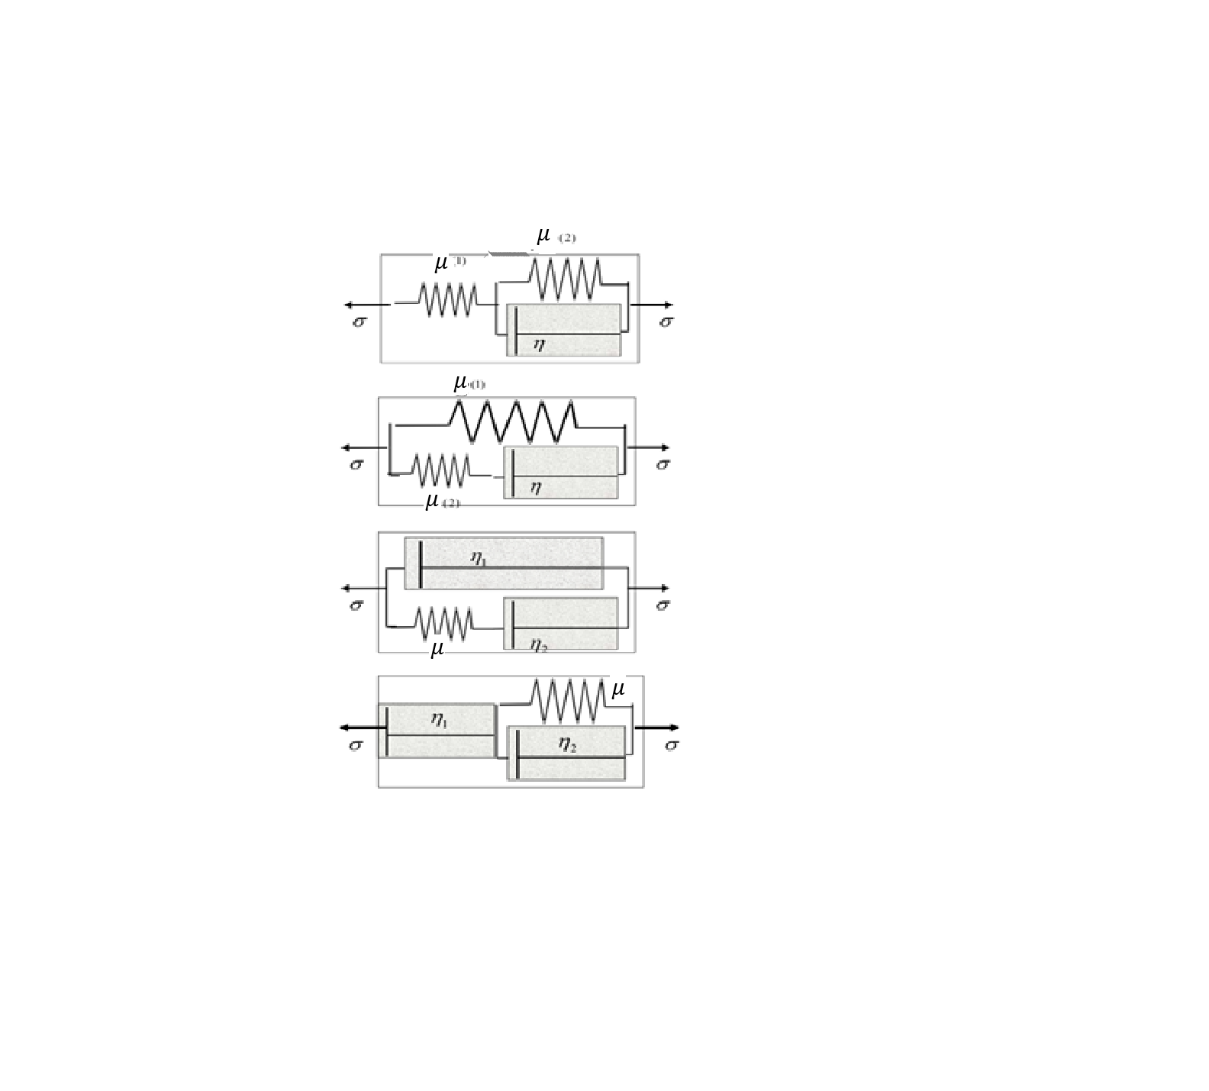

Figure four illustrations of models with springs and dashpots arrenged in both series and parallel with modified code letters

The constitutive expression for each model is respectively:

(49)

(50)

(51)

(52)

In the next section non-linear models will be analyzed.

##### Interconversion Between Creep Compliance and Relaxation Function

The creep compliance function and the relaxation function are correlated to each other by the Laplace transform. The interrelation between these two functions is going to be exposed in this study only for linear viscoelasticity, since both functions depend only of time.

Using the Boltzmann integrals presented in (26) and (27) and converting the convolutional by the Laplace transform it can be found that (Lakes & Vanderby, 1999):

(53)

(54)

Where s is the transform variable. With simple algebraic manipulations both equation (53) and (54) can turn into:

(55)

(56)

Making these two expressions equal:

(57)

Converting back the equation with inverse Laplace transform it can be found that since:

(58)

And remembering that a multiplication in the Laplace spectra is turned into convolution integral, then:

(59)

This interrelation is due also to the commutativity of the convolution. This behavior can be graphically described as:

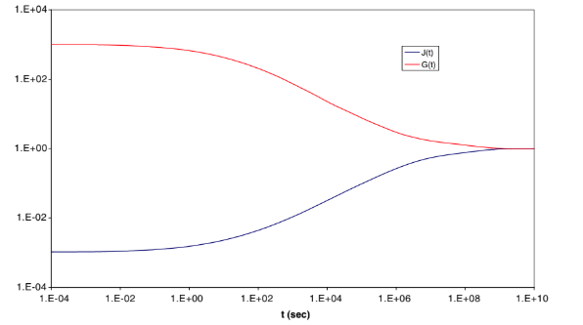

Figure Graphic of Creep compliance J(t) and relaxation function G(t) per time (Park & Schapery, 1998) (Anderssen, Davies, & Hoog, 2008)

This is a log-log graph that uses the data presented in (Park & Schapery, 1998) and plotted by (Anderssen, Davies, & Hoog, 2008).

This interconversion is theoretical. However, it has high importance for the applicability of the viscoelastic models. That occurs since the relaxation function’s and the creep compliance’s parameters are not often simple to achieve. Therefore, one of the functions can be found experimentally while the other is detected by the interconversion expression.

#### Non-linear model

Until now the used equations were only one variable dependent. However, in many real situations these approaches reveals to be insufficient. In fact, the linearity can only be considered if the strain is assumed to be very small. Whereas, the non-linearity considers the strain not as a sum of discrete strains, but as a continuous unique strain that varies among time, as in the following equation (Duenwald-Kuehl, Vanderby Jr., & Lakes, 2009):

(60)

It can also be observed that in non-linear viscoelasticity, the relaxation function *G* is not only dependent of time, but also strain dependent. Consequently, the expression (40) cannot be used. Nevertheless, an improvement of equation (23) can be used:

(61)

Where ε is no longer constant. The non-linear viscoelastic model is widely used for polymers and biological materials.

### Schapery’s Model

Schapery presented in (Schapery R. A., 1969)a generalized non-linear viscoelastic model based in thermodynamic concepts. This theoretical model has a huge importance since it describes various sorts of materials such as polymers, metals, and soft tissues. The mathematical behavior of this method will be expressed in detail in this part. The full constitutive expressions are:

(62)

(63)

The J0 and J are respectively the creep compliance components of initial value and transient, where J = J(t) – J0. Analogously, Ge and G are the relaxation function components where Ge is equilibrium one and G the transient and G = G(t) – Ge.

Furthermore, the g0, g1 and g2 are stress dependent coefficients with thermodynamic applications. As explained in (Haj-Ali & Muliana, 2003), g0 is the non-linear elastic response that calculates the instantaneous change in stiffness, g2 is the non-linear transient response and g2 is the parameter that measures load rate effects in creep. The letter g and the numbers indicate the Gibb’s free energy dependence and its order.

Lastly, the ϕ and ρ variables are reduced-time parameters. Like the relaxation time τ, reduced-time is a temporary parameter that depends on the material, but it goes further to its thermodynamic conditions. It is known that, for example, a material in low temperatures takes longer times to relax. In order to express this and other variables that affect the relaxation and creep compliance times, the reduced-time was created. Obviously, ϕ is the reduced-time corresponding to creep compliance, ρ is the one corresponding to stress relaxation, and its functions are:

(64)

(65)

As observed, both reduced-times has a parameter. These are the shift factors. They are based on the time-temperature superposition principle and the time-temperature-stress superposition principle (Pindera, 1981) (Roth, 2016).

The time-temperature superposition principle presents a temperature dependence in time as illustrated in the last paragraph, introducing than a shift factor for the stress relaxation and creep compliance times that are mostly temperature dependents:

(66)

Where at is the temperature dependent shift factor, k1 and k2 are constants related to the material and T0 is reference temperature (Findley & Davis, 2013). This equation for the temperature shift factor is the famous WLF equation (Williams, Landel, & Ferry, 1955), presented in order to generalize the Arrhenius equation, a linear logarithmic relation between the material constants and the temperature (Ashter & Ali, 2014). The WLF equation has a larger range of temperatures where the relation is valid, that is what makes it more generalized.

Schapery in (Schapery R., 1966) and (Schapery R., 1969) introduced the so called vertical shift factor, the ones that depend on stress and strain, aσ and aε respectively.

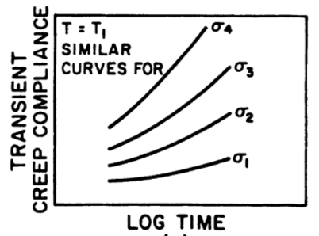

Figure Transient Creep Compliance (J) versus Log time according to the stress (Pindera, 1981)

Figure Transient Creep Compliance (J) versus Log time according to the stress for Poly (methyl methacrylate) (Luo, Wang, & Zhao, 2007)

Figures 21 and 22 show how the creep compliance time varies according to the stress, that is, lower stresses take longer transient creep compliance times. Analogously, the relaxation time varies according with the strain input (Luo, Wang, & Zhao, 2007). Hence, that is where the stress and strain shift factors enter in order to quantify this relation.

Creep compliance value is the same independently of the stress, as equation (36) indicates. However, different stresses produce different time scales (Luo, Wang, & Zhao, 2007).

Time-temperature superposition and time-temperature-stress superposition principal are both largely used for polymer material as well as Schapery’s expressions due to its temperature parameters. It is known that biological tissues and materials hardly suffer temperature changes, but concept and equations are still valid.

## Quasi-Linear Model

This model was created by Fung (Fung, 1993) to apply the non-linearity of the stress-strain relation expressing the relaxation function in two parts: the reduced relaxation function g(t), which depends only on time, like in the linear model, and the elastic response σ(ε) the depends entirely on strain. This last term is the corresponding stress for an instantaneous strain in the material. The expressions that this model is based are:

(67)

(68)

Expression (68) clearly exposes the role of the elastic response as a Heaviside step function, as an impulsive stress response and the reduced relaxation function as the signal that displaces the function in time. The definition of g(t) can be considered equal to (40). That is due to the theoretical proposal of Fung that the non-linearity of the constitutive equation is given by the elastic response, which will be seen further. However, the decay of the stress after a step function, for example, is given by a linear reduced relaxation function g(t).

Furthermore, the elastic response σ(ε) must be defined and it is chosen an exponential function:

(69)

And, A and B are constants calculated by (Woo, Gomez, & Ackeson, 1981)based in the nonlinear least-square curve-fitting method. That found A = 0.193 and B = 161.

The quasi-linear viscoelastic theory is mainly applied for the calculus of biological tissues, where the linear approach is proved to be inadequate and the numerical technique of the non-linear model is often too complex.

## Application of the Mathematical Model in Soft Tissue

Ligaments are soft tissues responsible for connecting bone to bone. They belong to the musculoskeletal system and have viscoelastic properties.

A soft tissue, as a knee ligament, was proved to not present linearity in its viscoelastic behavior (Provenzano P. , Lakes, Keenan, & Vanderby, 2001). Due to that, the quasi-linear expressions will be applied in the experimental tests that were made.

So that can be done, some coefficients must be specified: μ = 372 MPa (Completo, Noronha, Oliveira, & Fonseca, 2017), considering a medial collateral ligament as example, t = 0,1;30s, τ = 1.6s (Sopakayang, 2010). Furthermore, the diameter of an average MCL is 11.3mm (Otake, Chen, Yao, & Shoumura, 2007).

The numerical application of the viscoelastic models requires certain software programs. This computational modeling will be explained in the further section.

### Software Programs

The first software used in order to calculate results with the viscoelastic models and generate graphs was MathCad. It proved to be a very useful program for the linear viscoelastic model and for applications of convolution in vibrations, since it is very intuitive, and it worked as expected. However, when the quasi-linear viscoelastic model with its parameters were input the software presented errors and would not calculate and present graphs as the linear model did.

Therefore, the software used next was Visual Basic for Applications available in Excel. This program is not as intuitive as MathCad, but it has more programming tools so that the more complex viscoelastic models can be numerically applied.

# Bibliografia

(13 de November de 2019). Fonte: https://zeus.plmsc.psu.edu/~manias/MatSE447/05_LinearViscoelasticity.pdf

(6 de November de 2019). Fonte: https://mail-attachment.googleusercontent.com/attachment/u/0/?ui=2&ik=05b99c6450&attid=0.1&permmsgid=msg-a:r-6499423707817302675&th=16e41ff19461fc6d&view=att&disp=inline&realattid=f_k2nmfvge0&saddbat=ANGjdJ-Oh9YnTCN2XHQxzgQr7QhQv0JBfHpRFJRDFRg7teRtW_z3Np6

(10 de June de 2020). Fonte: Renaissance Research Labs: https://www.r2labs.org/references/Convolution.pdf

(11 de June de 2020). Fonte: Math Works: https://www.mathworks.com/matlabcentral/mlc-downloads/downloads/submissions/23978/versions/3/screenshot.jpg

Abramowitch, S. D., & Woo, S. L.-Y. (2004). An Improved Method to Analyze the Stress Relaxation of Ligaments Following a Finite Ramp Time Based on the Quasi-linear Viscoelastic Theory. *Journal of Biomechanical Engineering*.

Abramowitch, S. D., Woo, S. L.-Y., Clineff, T. D., & Debski, R. E. (2004). An evaluation of the quasi-linear viscoelastic properties of the healing medial collateral ligament in a goat model. *Annals of Biomedical Engineering*.

*All About Circuits*. (17 de June de 2020). Fonte: https://www.allaboutcircuits.com/technical-articles/better-insight-into-dsp-learning-about-convolution/

*All About Circuits*. (17 de June de 2020). Fonte: https://www.allaboutcircuits.com/technical-articles/two-dimensional-convolution-in-image-processing/

Anderssen, R. S., Davies, A. R., & Hoog, F. R. (2008). On the Volterra integral equation relating creep and relaxation.

Ashter, & Ali, S. (2014). *Thermoforming of Single and Multilayer Laminates.*

Babaei, B., Davarian, A., Pryse, K. M., Elson, E. L., & Genin, G. M. (2015). Efficient and optimized identification of generalized Maxwell viscoelastic relaxation spectra. *Journal of the mechanical behavior of biomedical materials*.

Britannica. (30 de June de 2020). *Encyclopaedia Britannica*. Fonte: https://www.britannica.com/science/elasticity-physics

Completo, A., Noronha, J. C., Oliveira, C., & Fonseca, F. (2017). Análise biomecânica da reconstrução do ligamento cruzado anterior. *Thieme Revnter Publicações Ltda*.

*COMPOSITE CONSTRUCTION*. (2020). Fonte: http://fgg-web.fgg.uni-lj.si/~/pmoze/ESDEP/master/wg10/l0520.htm

Cordeiro da Silva, A. R. (1997). *Sobre o comportamento viscoelástico das estruturas: relações constitutivas e técnicas numéricas.*

Danto, M., & Woo, S. (1993). The mechanical properties of skeletally mature rabbit anterior cruciate ligament and patellar tendon. *Journal of Orthopaedic Research*.

Davis, F. M., & De Vitta, R. (2013). A Three-dimensional Constitutive Model for the Stress Relaxation of Articular Ligaments. *Biomechanics and Modeling in Mechanobiology*.

De Vitta, R., & Slaughter, W. S. (2005). A structural constitutive model for the strain rate-dependent behavior of anterior cruciate ligaments. *International Journal of Solids and Structures*.

Downs, A. (s.d.). *An Introduction to Rheology and Its Applications.*

Duenwald, S. E., Vanderby Jr, R., & Lakes, R. S. (2010). Stress relaxation and recovery in tendon and ligament: Experiment and modeling. *Biorheology*.

Duenwald-Kuehl, S., Vanderby Jr., R., & Lakes, R. (2009). Viscoelastic Relaxation and Recovery of Tendon. *Annals of Biomedical Engineering*.

Eisencraft, M. (2007). Processamento Digital de Sinais.

Fagundes, J. S., & Vassoler, J. M. (2019). A study of biphasic models to represent the viscous mechanical behavior of tendons. *Journal of Mechanical Engineering and Biomechanics*.

Findley, W. N., & Davis, F. A. (2013). *Creep and relaxation of nonlinear viscoelastic materials.* Courier Corporation.

Fratzl, P., Misof, K., Zizak, I., Rapp, G., Amenitsch, H., & Bernstorffd, S. (1998). Fibrillar structure and mechanical properties of collagen. *Journal of Structural Biology*.

Fung, Y. (1993). *Biomechanics: Mechanical Properties of Living Tissues.* Springer.

Funk, J. R., Hall, G. W., Crandall, J. R., & Pilkey, W. D. (2000). Linear and Quasi-Linear Viscoelastic Characterization of Ankle Ligaments. *Journal of Biomechanical Engineering*.

Gripenberg, G., Londen, S. O., & Staffans, O. (1990). *Volterra Integral and Functional Equations.*

Grupo de Reelaboração do Ensino de Física. (2002). *Física 1: Mecânica.* edUSP.

Guo, Z. Y., Peng, X. Q., & Moran, B. (2006). A new nonlinear viscoelastic model and mathematical solution of solids for improving prediction accuracy. *Journal of Mechanics and Physics of Solids*.

Haj-Ali, R. M., & Muliana, A. H. (2003). A micromechanical constitutive framework for the nonlinear viscoelastic behavior of pultruded composite materials. *International Journal of Solids and Structures* .

Jamison, C. E., Marangoni, R. D., & Glaser, A. A. (1968). Viscoelastic properties of soft tissue by discrete model characterization. *Journal of Engineering for Industry*.

Jerri, A. (1985). *Introduction to Integral Equations with Applications.*

Jerushim, M. C., Balaban, P., & Shanmugan, K. S. (2000). *Simulation of Communication Systems: Modeling, Methodology and Techniques.* New York: Kluwer Academic Publishers.

Joyce, P. D. (2014). *Sums and Convolution Math 217 Probability and Statistics.*

Kelly, P. (2012). *Engineering Solid Mechanics.*

Lakes, R. S., & Vanderby, R. (1999). Interrelation of creep and relaxation: a modeling approach for ligaments. *Journal of Biomech. Engineering*.

Ludwig. (17 de June de 2020). Fonte: Image Convolution: http://web.pdx.edu/~jduh/courses/Archive/geog481w07/Students/Ludwig_ImageConvolution.pdf

Luo, W., Jazouli, S., & Vu-Khanh, T. (2007). Modeling of Nonlinear Viscoelastic Creep of Polycarbonate. *E-Polymers*.

Luo, W., Wang, C., & Zhao, R. (January de 2007). Application of Time-Temperature-Stress Superposition Principle to Nonlinear Creep of Poly(methyl methacrylate). *Key Engineering Materials*.

Martins, P. A., Natal Jorge, R. M., & Ferreira, A. J. (2006). A Comparative Study of Several Material Models for Prediction of Hyperelastic Properties: Application to Silicone‐Rubber and Soft Tissues.

Mase, G. T., & Mase, G. E. (1999). *Continuum Mechanics for Engineers.*

Massachusetts Institute of Technology: Department of Electrical Engineering and Computer Science. (2006). *Linear Filtering with the DFT.*

Miller, K. (1998). Constitutive model of brain tissue suitable for finite element analysis of surgical procedures. *Journal of Biomechanics*.

Miller, K., & Chinzei, K. (1997). Constitutive modelling of brain tissue: Experiment and theory. *Journal of Biomechanics*.

Nekouzadeh, A., Pryse, K. M., Elson, E. L., & Genin, G. M. (2007). A simplified approach to quasi-linear viscoelastic modeling. *Journal of Biomechanics*.

Otake, N., Chen, H., Yao, X., & Shoumura, S. (2007). Morphologic Study of the Lateral and Medial Collateral Ligaments of the Human Knee.

Park, S. W., & Schapery, R. A. (1998). Methods of Interconversion between linear viscoelastic material functions. Part I - a numerical method based on Prony series.

Pindera, J. T. (1981). *New physical trends in experimental mechanics.* Springer.

Pioletti, D. P., & Rakotomana, L. R. (2000). Non-linear viscoelastic laws for soft biological tissues. *European Journal of Mechanics*.

Pioletti, D., Rakotomanana, L., Benvenuti, J., & Leyvraz, P. (1998). Viscoelastic constitutive law in large deformations: Application to human knee ligaments and tendons. *Journal of Biomechanics*.

Pipkin, A., & Rogers, T. (1968). A non-linear integral representation for viscoelastic behaviors. *Journal of the Mechanics and Physics of Solids*.

Provenzano, P., Lakes, R. S., Corr, D. T., & R., V. J. (2002). Biomechanics in Modeling in Mechanobiology.

Provenzano, P., Lakes, R., Keenan, T., & Vanderby Jr, R. (2001). Nonlinear Ligament Viscoelasticity. *Annals of Biomedical Engineering*.

Provenzano, P., Lakes, R., Keenan, T., & Vanderby, R. J. (2001). Nonlinear Ligament Viscoelasticity. *Annals of Biomedical Engineering*.

Qinwu, X., Engquist, B., Solaimanian, M., & Yan, K. (2020). A new nonlinear viscoelastic model and mathematical solution of solids for improving prediction accuracy. *Scientific Reports (Nature Publisher Group)*.

Quaia, C., Ying, H. S., & Optican, L. M. (2009). The Viscoelastic Properties of Passive Eye Muscle in Primates. II: Testing the Quasi-Linear Theory.

Rao, S. S. (2009). *Vibrações Mecânicas.* Pearson.

Ristaniemi, A. (2018). Comparison of elastic, viscoelastic and failure tensile material properties of knee ligaments and patellar tendon. *Journal of Biomechanics*.

Roth, C. B. (2016). *Polymer Glasses.* C R C Press.

Schapery, R. (March de 1966). A Theory of Nonlinear Thermoviscoelasticity Based on Irreversible Thermodynamics.

Schapery, R. (February de 1969). Further Development of Thermodynamic Constitutive Theory: Stress Formulation.

Schapery, R. A. (10 de January de 1969). On the Characterization of Nonlinear Viscoelastic Materials. p. 16.

Sopakayang, R. (2010). Viscoelastic Models for Ligaments and Tendons.

Srivastava, H. M., & Buschman, R. G. (1992). *Theory and Applications of Convolution Integral Equations.* Springer.

Sullivan, R. W., Razzaghi, M., & Simsiriwong, J. (2010). Numerical iterative method for Volterra equations of the convolution type.

Troyer, K. L., Estep, D. J., & Puttlitz, C. M. (2011). Viscoelastic effects during loading play an integral role in soft tissue mechanics. *Acta Biomaterialia*.

Troyer, K. L., Shetye, S. S., & Puttlitz, C. M. (2012). Experimental Characterization and Finite Element Implementation of Soft Tissue Nonlinear Viscoelasticity. *Journal of Biomechanics*.

Wang, X., Zhao, K., & Zhao, H. (2018). FINITE ELEMENT SIMULATION OF BIOFILM VISCOELASTIC BEHAVIOR UNDER VARIOUS LOADINGS. *Journal of Mechanics in Medicine and Biology*.

Weinerowska-Bords, K. (2015). Alternative Approach to Convolution. *Journal of Fluids Engineering Term of Viscoelasticity in Equations of Unsteady Pipe-Flow*.

Williams, M. L., Landel, R. F., & Ferry, J. D. (1955). The temperature dependence of relaxation mechanisms in amorphous polymers and other glass-forming liquids. *Journal of the American Chemical society*.

Woo, S. L., Chan, S. S., & Yamaji, T. (1997). Biomechanics of Knee Ligaments Healing, Repair and Reconstruction. *Journal of Biomechanics*.

Woo, S. L.-Y., Gomez, M. A., & Ackeson, W. H. (1981). The Time and History-Dependent Viscoelastic Properties of the Canine Medial Collateral Ligament.

Zheng, N., Fleisig, G. S., Escamilla, R. F., & Barrentine, S. W. (1998). An analytical model of the knee for estimation of internal forces during exercise. *Journal of Biomechanics*.